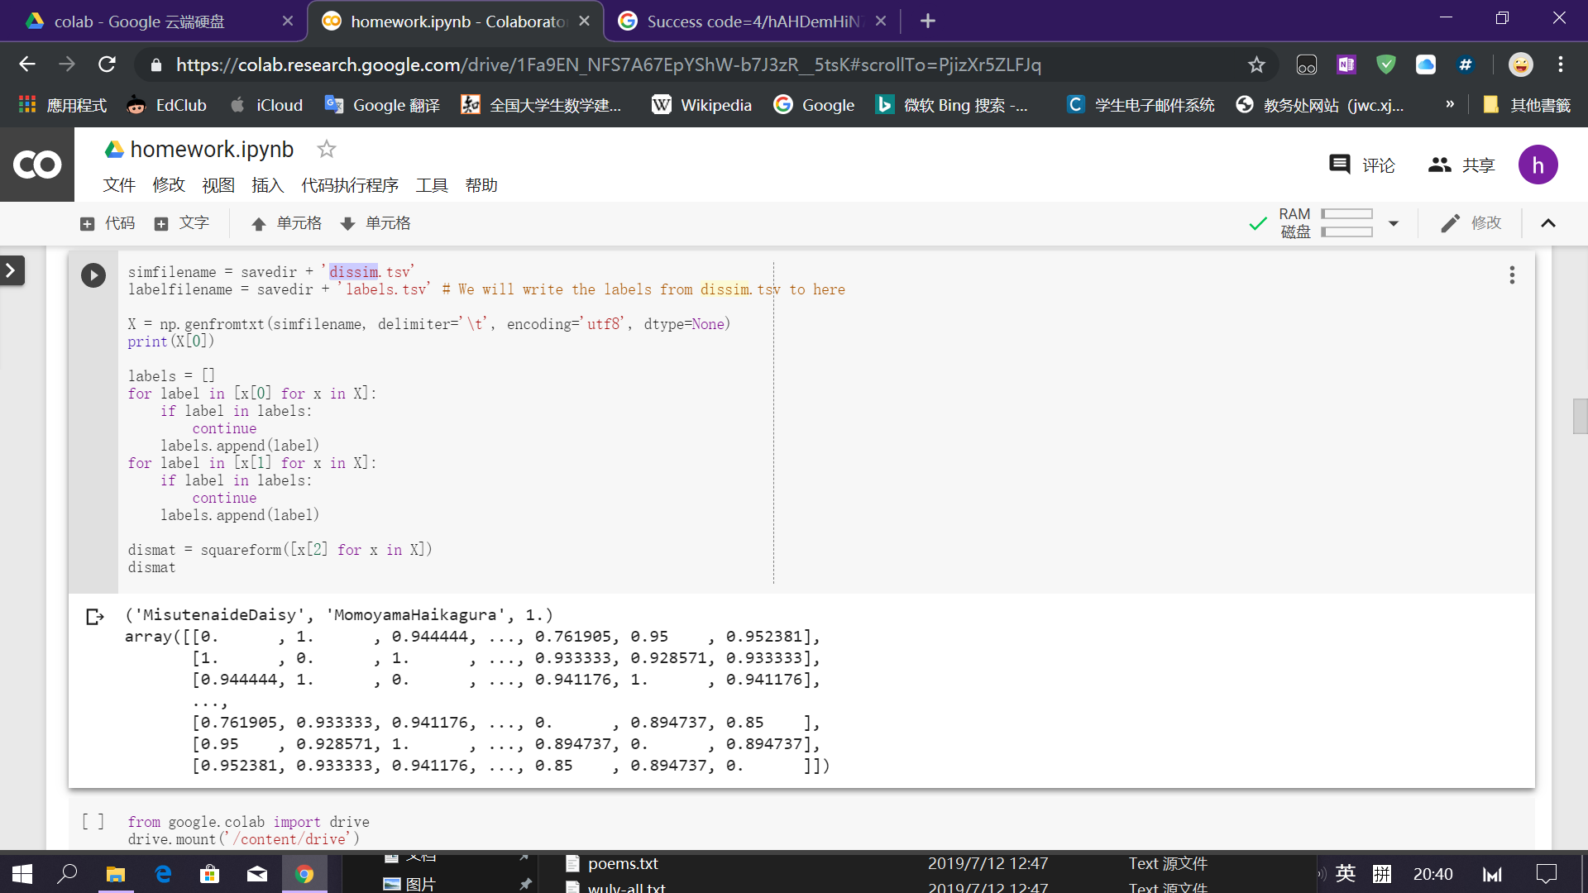

simfilename = savedir + 'input_data.csv'

labelfilename = savedir + 'labels.tsv' # We will write the labels from dissim.tsv to here

X = np.genfromtxt(simfilename, delimiter=',', encoding='utf8', dtype=None)

labels = []

for label in [x[0] for x in X]:

if label in labels:

continue

labels.append(label)

for label in [x[1] for x in X]:

if label in labels:

continue

labels.append(label)

dismat = [x[2] for x in X]

dismat

simfilename = savedir + 'dissim.tsv'

labelfilename = savedir + 'labels.tsv' # We will write the labels from dissim.tsv to here

X = np.genfromtxt(simfilename, delimiter='\t', encoding='utf8', dtype=None)

labels = []

for label in [x[0] for x in X]:

if label in labels:

continue

labels.append(label)

for label in [x[1] for x in X]:

if label in labels:

continue

labels.append(label)

dismat =squareform([x[2] for x in X])

print([x[2] for x in X])

dismat